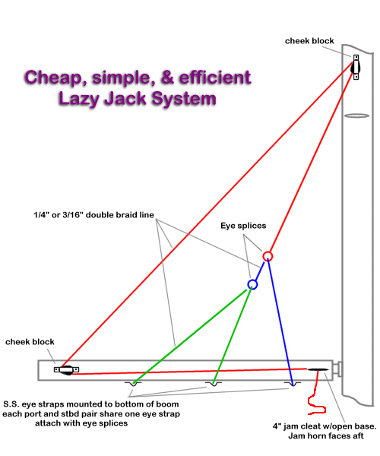
The cheek block on the boom is located so that the jack line passes about 6" forward of the longest batten (full batten main). The cheek block on the mast is above the spreaders and approx 1/3 the distance from the spreaders to the mast head. The circles indicated on the red and blue lines are eye splices. You might do well to add nylon horned thimbles to reduce friction. You could get real fancy and put some blocks there but you reduce the simplicity and increase the weight. Position the center eye strap so that a line running from the mast cheek block to the center eye strap bisects the triangle formed by the aftermost jackline and the mast. Then. split the difference between the boom cheek block and the center eye strap and place the second eye strap there. Place the forward eye strap about 6" aft of the after end of the jam cleat.
To stow the rig simply uncleat the lines that pass through the cleats, with the bitter end in your forward hand, walk back to the aft jackline, grab it a few feet above the boom and pull it forward and down toward the cleat gather up the other lines as you come to them. Place the four lines under the cleat's forward horn and snug them all up by alternately pulling on lines 2 or 3 feet above the boom and taking up the slack on the bitter end. Cleat it off and they are out of the way until you are ready to drop your sails again. Deploy the system on both sides prior to letting go the main halyard (hardening the deployed jacks will tend to lift the boom so set one side and then snug up the other until the set side starts to slack, ease up until the tension is the same on both sides). Drop and flake the sail and restow the jacks once the gaskets are in place.

